Racism: Research Paper
Name
Professor
Course
Date

Racism
Introduction
This research revisit the debate on racism, by first examining the events associated with Hurricane Katrina, not with a view of discussing the hurricane but elicit thoughts on racism subject, and probably to examine different aspects of racism and how evident they occur in communities around us.
It has been observed that the impact of Hurricane Katrina was disastrous by all measures. Other than billions of dollars of damage and a premier city in the United States left to a great extent in ruins, 1,100 to 1,700 people died and thousands more are yet to be unaccounted for (Burchfiel, 2006). What's more, Hurricane Katrina was especially devastating for Black Americans. The flooding caused by the hurricane was especially damaging to Black neighbourhoods that were generally uninsured against surges. Many Blacks in New Orleans who survived yet were displaced by Hurricane Katrina were not able to return to the city and to the community where they once lived. In the outcome of Hurricane Katrina, allegations relating to the absence of planning for the storm and for the predicament of its victims were heatedly traded. Racism was one focal point of the discussion. On one side, it was declared that the deficient reaction to the storm and the flooding was because of evident racism. This opinion is obvious in a statement by Kanye West, a popular rapper, who stated, "George Bush does not care about Black people" (Broder, Wilgoren, and Alford, 2005). In response, for example, Secretary of State Condoleeza Rice resolvedly denied that race had anything to do with Hurricane Katrina or the government's reaction to it, and that no one, particularly the President, would have left people unattended based on race (Broder et al., 2005).
From a social psychological point of view, the two sides seemed to distort the circumstance, and clouded the potential roles of historical elements, institutional discrimination, and contemporary subtle types of individual racism, all of which likely played parts in the impact of Hurricane Katrina and the administration's reaction to it.
However, to understand whether or not racism and other government policy failure were to blame, one needs to deeply understand racism issues. This paper seeks to provide and highlight certain general aspect of racism.
Racism in Perspective
Feagin and Vera (1995) clarify, "Racism is in excess of a matter of individual scattered scenes of discrimination," it speaks to a broadly acknowledged racist belief system and the ability to deny other racial groups the "respect, openings, opportunities, and prizes that are accessible to one's group through a socially sorted out set of thoughts, states of mind, and practices".
Despite the fact that racism relates straightforwardly to the organized communication of generalizations, racism, and discrimination, it includes more than individual inclinations. Racism reflects institutional, social, and social impacts, also. As indicated by Jones (1997), at its exceptionally embodiment racism includes negative states of mind and convictions, as well as the social power that makes an interpretation of them into divergent results that impediment different races or offer novel focal points to one's own race to the detriment of others.
While the investigation of racism and discrimination centers around the jobs of people and relational procedures, racism includes institutional, social, and social procedures that fill in as a compelling setting to individual level points of view. Institutional racism, for instance, refers to the purposeful or accidental control or toleration of institutional strategies (e.g., survey charges, confirmations criteria) that unjustifiably limit the chances of specific groups of people, and cultural racism includes convictions about the prevalence of one's racial social legacy over that of different races and the declaration of this faith in individual activities or institutional policies (Jones, 1997).
Individual discrimination refers to the conduct of individual people from one race/ethnic/gender gather that is planned to have a differential or potentially unsafe impact on the people from another race/ethnic/sex group (Pincus, 2000). Like institutional and cultural racism, individual racism is likewise generally showed quietly, frequently without cognizant mindfulness or aim. Numerous contemporary ways to deal with individual racism recognize the diligence of clear, deliberate types of racism yet in addition consider the role of programmed or oblivious procedures and backhanded articulations of predisposition (Henkel et al, 2016).
Institutional discrimination, then again, is very unique since it refers to the strategies of the predominant race/ethnic/gender and the conduct of people who control these foundations and actualize policies that are proposed to have a differential and additionally destructive impact on minority race/ethnic/gender groups. Jim Crow isolation in the South amid the primary portion of the twentieth century is one clear model. State laws ordered the partition of Blacks and Whites in all everyday issues. Utilizing any of the one-hour sections of the Eyes on The Prize narrative on the Civil Rights development is a fantastic method to represent the recorded idea of institutional discrimination (Pincus, 2000).
Also, both contemporary individual and institutional racism regularly work without Whites' expectation to hurt people from minority groups or even mindfulness by Whites of their own rolein disadvantaging Blacks. For example, applying policies that appear to be simply and libertarian dependent on quick standards of reasonableness in a restricted sense may deliberately inconvenience groups that for verifiable reasons have less contemporary assets (e.g., riches or training) that would enable them to profit completely from these approaches and techniques (Dovidio, Mann, and Gaertner, 1989). Along these lines, Whites' verifiable victimization Blacks creates an inheritance of difference that might be sustained even by good natured people who support and exercise current approaches that have different ramifications for Whites and Blacks. Besides, cultural racism offers need to the estimations of the dominant part group, which are implanted in generally acknowledged social belief systems (Sidanius and Pratto, 1999). Policies, laws, and strategies that mirror these values might be quietly mutilated in manners that upgrade the disservice of minority groups and the benefit of the majority group. Consequently, when a racial group and its people have been verifiably burdened, the outcomes are wide and extreme, imitating themselves crosswise over time (Jones, 1997).
Global Racism Index
Racial pressures have dependably existed in the Western setting, however they turned into a danger to solidness in the European Union in the most recent years, achieving pinnacles of racial inclination in nations like Italy, the Czech Republic and other Eastern European countries. In the United Kingdom, the offer of respondents saying that they were, in any event to some degree, preferential when it came to people of different races topped in 2011 and demonstrated a pattern of increment in the most recent years. In 2016, the dominant part of Norwegians studied communicated effect about developing xenophobia and threatening vibe toward outsiders and exiles (Statista, 2018).
Physical and verbal racial brutality expanded in the course of the most recent decade in most European nations. In Italy, for instance, 25 instances of racial physical savagery were enlisted in 2014 in addition to a sum of 916 instances of racial verbal viciousness. In 2014/15, the quantity of racist offenses enlisted in Northern Ireland crested at a sum of 310 offenses including brutality yet not damage. Race is the most well-known inspiration of abhor violations: somewhere in the range of 2015 and 2016 around 13.4 thousand racially spurred despise crimes were recorded in London. In 2015, 68 scenes of physical ambush were identified with loathe crime in Italy (Statista, 2018) (Table 1)
Scenes of abhor discourse are on the ascent. In Italy, an everyday normal of 0.48 scenes every day of detest discourse against Roma and Sinti were enlisted in 2016, while 55 per cent of French guys were presented to racist articulations online in 2015. Indeed, most French people trust that posting content on the web secretly energizes abhor discourse. Five per cent of Swedish Internet clients expressed that they frequently incidentally experienced material which advances racial disdain on the web, while just three per cent of Finnish clients regularly experienced such circumstances (Statista, 2018).
Other study shows that Anglo and Latin nations are generally tolerant. People in the survey were destined to grasp a racially different neighbor in the United Kingdom and its Anglo previous settlements (the United States, Canada, Australia and New Zealand) and in Latin America. The main genuine special cases were oil-rich Venezuela, where pay inequality once in a while breaks along racial lines, and the Dominican Republic, maybe as a result of its nearness harried Haiti. Scandinavian nations likewise scored high (Fisher, 2013) (See: Map).
Fisher (2013) sees that India and Jordan by a long shot the minimum tolerant. In just two of 81 reviewed nations, in excess of 40 per cent of respondents said they would not need a neighbor of an alternate race. This included 43.5 per cent of Indians and 51.4 per cent of Jordanian. The Middle East was not all that tolerant – where movement was additionally a major issue in this area, especially in Egypt and Saudi Arabia, which frequently retain financial transients from poorer neighbors; and, racial resistance was low in various Asian nations. Countries, for example, Indonesia and the Philippines, where numerous racial groups regularly move for impact and have muddled accounts with each other, demonstrated more suspicion of decent variety. This was likewise valid, to a lesser degree, in China and Kyrgyzstan. There were comparative patterns in parts of sub-Saharan Africa (Fisher, 2013).
U.S.A Racism Index
A torrential slide of surveying in the course of the most recent three years, a lot of it incited by police killings of African-Americans that snatched features in 2014 and 2015, indicate how people of various racial foundations have uncontrollably extraordinary American encounters. Popular supposition surveying illustrates wide incongruities between African-Americans and different minorities contrasted with whites. Black Americans see - and encounter - racial discrimination more than white Americans (Struyk, 2017).
Basically non-whites will in general observe racial discrimination significantly more than whites do. Investigate these numbers: A mind-boggling 87% of Black Americans say Black people confront a ton of discrimination in the United States, however just 49% of white Americans say a similar thing, as per a February survey from the Public Religion Research Institute (Struyk, 2017).
Looking forward, a staggering 88% of blacks say the nation needs to continue rolling out improvements for blacks to have measure up to rights with whites. A little majority (53%) of whites concur with them, as indicated by a Pew Research survey from last June. What's more, blacks appear to be less hopeful about that is going on. About portion of that group (43%) is incredulous that these progressions will ever occur in the United States, while just a single in 10 whites (11%) say they're dicey the nation will in the end change (Struyk, 2017).
Generally speaking, a dominant part think white people profit by focal points in the public eye that Black people don't have. Among blacks, 84 per cent said white people advantage a lot or considerable measure. Among Hispanics, 71 per cent said white people advantage and 25 per cent said they don't. However, half of white people said they hate any points of interest, when contrasted with 47 per cent of white people who said they did (Arenge et al, 2018) (Table 2).
The racial divisions proceed with: seventy five per cent of blacks say police will probably utilize constrain against a Black individual than a white individual, while a dominant part of whites (56%) say race doesn't make a difference. A majority of whites (53%) say they are certain police treat whites and blacks similarly in the United States versus a majority of blacks (57%) who say they are "not sure by any means." And six of every 10 whites say police shootings of blacks are detached occurrences, while more than seven out of 10 non-whites say they are an indication of more extensive issues.
In May 2016, general society was discriminated about whether racial issues had gotten excessively (36%) or too little (35%) consideration; about a quarter (26%) said they had gotten in regards to the perfect measure of consideration (Pew Research, 2017) (Table 3).
The survey finds that a lion's share of Americans (65%) keep on saying there are "very strong" or "strong" conflicts among blacks and whites in the U.S. However, unmistakably (86%) say there are strong conflicts among Republicans and Democrats than say the equivalent in regards to conflicts among blacks and whites, youngsters and more established grown-ups, rich and needy people, and between the people who live in country and urban zones (Pew Research, 2017). By differentiation, in May 2016, about the same number of thought relations were deteriorating (38%) as said they were holding enduring (41%); 19% said they were improving (Table 4).
Among blacks, about half (51%) now say race relations are deteriorating, up 14 rate focuses since a year ago. Feeling among whites stays partitioned: While 41% think relations are deteriorating, about the same number of (37%) say they are remaining the equivalent; 20% think race relations are showing signs of improvement.
There additionally have been factional moves in sentiments about the direction of race relations. About portion of Democrats and Democratic-inclining independents (49%) say race relations are deteriorating, contrasted and 32% in May 2016. Republicans and Republican supporters are currently to some degree more averse to state race relations are deteriorating (45% at that point, 38% today).
Racism and Ethnic Inequalities
Ethnicity is a term that depicts shared culture—the practices, values, and convictions of a group. This may incorporate shared dialect, religion, and customs, among different shared traits. Like race, the expression "ethnicity" is hard to depict and its importance has changed after some time. Ethnicity, similar to race, keeps on being a recognizable proof strategy that people and organizations utilize today—regardless of whether through the enumeration, governmental policy regarding minorities in society activities, non-discrimination laws, or basically in personal everyday relations (Little and McGivern, 2018).
Despite the fact that after some time, the way in which racial or ethnic discrimination is evidenced has changed in tone, the more up to date form is viewed as more in accordance with persecution than that of discrimination. This change can be ascribed to the way that society has made it more unthinkable to victimize people dependent on their hereditary cause. Actually, by and large, including work environments, business settings, and administration policies, a man isn't allowed lawfully to preclude a hopeful, irritate a colleague, dismiss a client, or reject administration to somebody dependent on the shade of his or her skin or other distinctive element, for example, an outside emphasize or ethnic style of dress.
New evidence of this compounding showed up in a report by the Pew Research Center (2011). The report concentrated on racial differences in riches, which incorporates a family's aggregate resources (pay, reserve funds and speculations, home value, and so forth.) and obligations (contract, charge cards, and so on.). The report found that the riches hole between white families from one viewpoint and African American and Latino family units then again was significantly more extensive than only a couple of years sooner, on account of the floundering US economy since 2008 that influenced blacks more seriously than whites.
An expanding measure of proof proposes that being Black in a general public loaded up with racial prejudice, discrimination, and inequality takes what has been known as a "concealed toll" on the lives of African Americans (Blitstein, 2009). As we will see in later parts, African Americans on the normal have more awful wellbeing than whites and kick the bucket at more youthful ages. Actually, consistently there are an extra 100,000 African American deaths than would be normal in the event that they lived insofar as whites do. Albeit numerous reasons most likely clarify every one of these variations, researchers are progressively inferring that the effect of being Black is a central point (Geronimus et al., 2010).
Importantly, it has been shown that African Americans are significantly more likely than whites to be poor, to live in high-crime neighborhoods, and to live in swarmed conditions, among numerous different issues. As this part talked about before, they are additionally more probable, regardless of whether they are poor, to encounter racial insults, refusals to be met for occupations, and different types of discrimination in their regular day to day existences. Every one of these issues imply that African Americans from their soonest ages grow up with a lot of effect, much more than what most whites involvement. This effect thusly has certain neural and physiological impacts, including (hypertension), that disable African Americans' here and now and long haul wellbeing and that eventually abbreviate their lives. These impacts collect after some time: highly contrasting hypertension rates are equivalent for people in their twenties, however the Black rate turns out to be substantially higher when people achieve their fifties. As an on-going news article on proof of this "concealed toll" outlined this procedure, "The long haul effect of living in a white-overwhelmed society 'weathers' blacks, making them age quicker than their white partners" (Blitstein, 2009).
Institutional Racism in Perspective
Institutional racism is one of the central issues concerning the inequality among blacks and whites in America. It is characterized as any arrangement, hone, monetary structure, or political structure that spots minority groups off guard in connection to the white network. Government funded school spending plans and nature of educators are a noteworthy locus of institutional racism in the United States, in view of the way in which spending plans are produced from property charges. Rich neighborhoods, comprising essentially of whites, have better government funded teachers and more cash for training. It might be anything but difficult to discount this reality as incident or as a result of the legitimacy based system, however social researchers have demonstrated something else (Massey 2007).
Essentially, racial profiling by law enforcement officers and the distortion of Black people in the media keep on making obstructions to advance. Obviously, the contention can be made that the issue of inequality is a result of social pathology or individual legitimacy. However, the best method to understand inequality among blacks and whites in the United States is to deliberately look at the advancement of organized racism (Benjamin, 2018).
In connection to institutional practices, there is some proof that stop-and-search rates are higher in certain local locations where there are no associative crime levels (MVA and Miller, 2000). Additionally, while 'racial profiling' isn't formally endorsed, it gives off an impression of being informally honed as stop and pursuit is an apparent pointer of execution by cops. Minority ethnic cops have revealed warning remarks by associates, for example, 'on the off chance that you see four Black young people in an auto, it merits giving them a draw, as no less than one of them will be liable of who knows what' (Cashmore,2001). Police authenticity in minority ethnic networks is apparently relinquished despite the fact that stop and pursuit has a to a great degree restricted effect on crime disturbance and recognition (Miller et al., 2000), in spite of this being the official justification for its continuation.
Regardless of signing the 1960s enactment expected to eradicate systemic racism from the political, social, and financial circles, there are still structures set up that propagate unjustifiable treatment and inequality inside our general public. A standout amongst other models can be found in the criminal equity system (Dalal, 2005). In fact, the United States detains a bigger number of people than some other nation, and relatively, African Americans have carried a lot of this weight. In view of the 2010 enumeration, 40 per cent surprisingly in the slammer in the United States were African American, despite the fact that African Americans comprised just 13 per cent of the populace. Drug related offenses assume a role in these numbers. In spite of comparable rates of drug use over all ethnicities, African Americans broadly are 3.7 occasions more prone to be captured for offenses including pot ownership. Compounding the issue, laws that expansion punishments for ownership in school zones disproportionally influence poor, urban African American people group (Oravecz, 2015).
Importantly, it has been observed that investigation of police organizational culture has additionally reliably demonstrated racial prejudice as a characterizing and underestimated highlight of 'cop culture' (Reiner, 1992). Earlier research had shown that the white, male, heterosexual inside culture of the police is opposing the new kind variety and uniformities policing. Such a reductionist clarification negates the overall autonomy of racism from economic and political relations (CCCS, 1982).
Racial Discrimination in Workplace
The impacts of discrimination in the work environment are indicated principally in two different ways. First, discrimination specifically causes the expanding rate of joblessness. Gender discrimination exists in a few organizations. There are organizations that do not employee women, and accordingly women have less openings for work. Also, age discrimination exists in different organizations. Youngsters may not find work after graduation, since a few organizations imagine that youngsters' absence of experience would not profit them. Just like the above gender and age discrimination so is racial discrimination, where organization prefer certain race over the other (Dalal, 2005).
One of the more troublesome parts of racial segregation at work, is that it can regularly happen totally undetected. After all, unless a business particularly concedes something else, who can state without a doubt why they settled on a specific choice to contract someone in particular or gave another a promotion? All things considered, there are a few examples where a business may show some prejudicial plan. For instance, with regards to interviewing, bosses commonly should not question an prospective employee's race. In the event that a business does as such, and chooses not to procure this worker, it might fill in as proof that race assumed a role in the choice. Such conditions are uncommon, in any case, and it ought to likewise be noticed that businesses may allowably get some information about race with regards to structures and governmental policy regarding minorities in society programs, insofar as they have no impact in the basic leadership process. (Dalal, 2005).
Effects of Racism
In U.S. society, discriminatory conduct against racial and ethnic groups isn't as adequate as it was before, in spite of the fact that despite everything it exists in a wide range of structures. In current times, racial inequalities can be found in the gaining influence of specific people, circulation of riches, outrageous neediness levels, tremendous quantities of jobless, and the perseverance of inequality word related class structures. World class racism is recreated at a national level through the media, the legislature, and other compelling figures. This racism is frequently veiled as the societal standard and in this manner goes unchallenged and is utilized to shape popular assessment (Nelson, 2015).
Apart from limiting access to social amenities, participation in various economic undertaking and employment, racial discrimination creates division by limiting certain workers to secondary markets not due to their education and aptitudes but rather in light of the fact that they have superficial characteristics resembling many workers in the auxiliary markets. Numerous workers in the auxiliary market have stable work despite the fact that their occupations support insecurity (Marshall, 2018).
Organizations pride themselves on making raving fanatics of their business. Unethical conduct, for example, racial discrimination, is disapproved of and will keep clients from returning. Organizations that discriminate employees based on race risk claims and expansive fines. Claims based on racial discrimination cause the organization to lose reputation and regard from their clients. Employees should feel good in the work environment. Deceptive conduct in the work environment will result in a lessening in the organization's resolve (Dalal, 2005).
Organizations that discriminate their employees by race hazard losing clients, patrons, and budgetary help, a possible diminishing in reputation, chance over the top fines and claims, and living with the hopeless result of dispiriting in the working environment. Frequently the group blamed for discrimination endeavors to conceal their wrong doings by accusing the worker's activity misfortune for spending cuts. At the point when dishonest conduct is going ahead in the work environment, organizations confront the loss of budgetary help from the network in which their business is found (Dalal, 2005).
Workers who feel victimized more often than not discover business somewhere else, costing the business lost time while scanning for a substitution. Studies have shown that racial discrimination could cause mental issues and higher feelings of anxiety. These mental issues incorporate sorrow, less fulfilment throughout everyday life, and abnormal amounts of nervousness. There have even been reports of feelings of anxiety being high to the point that the individual was hospitalized. Racial discrimination could likewise cause hypertension, sleep deprivation, migraines, and chest torments alongside different mental and physical issues. People not contracted in view of discrimination may respond in a savage nature because of indignation from the circumstance. They feel inadequate and could hurt those around. There have been different reports of aggressive behavior at home and in addition executing binges because of discrimination (Anderson, 2012)
Changes and Recommendations
For an organization to survive its business it must have policies and preventive measures for racism acts. This could be accomplished by mindfulness by associate survey, preparing, disciplinary acts, and even terminations. Organizations that take endeavors to achieve social decent variety are available to changes in corporate approaches that give impetuses for employees who increment profitability in their areas of expertise dependent on social assorted variety. Frequently, this converts into significant changes in corporate strategies, for example, in taking part in associate audits over the customary supervisor/subordinate situation. At the point when supervisors are looked into by those underneath them, there is to a lesser degree a shot that they will participate in racist remarks or activities.
Besides, the organization should give social decent variety preparing to their workers with the goal that they will know about their activities and words, that they may believe it's adequate to state or do however it's viewed as racist.
Institutional racism should be in an applied system which recognizes the role of racialization at the micro and macro scale levels, and can't fill in as the sole clarification for the ethnically unique welfare results that have for quite some time been watched. In the second segment of the paper, this staggered structure (which incorporates institutional racialisation) is connected to clarify ethnic inequalities in training (fulfilment) and policing (stop-and-hunt hones) (Phillips, 2011).
Other legitimate changes should address accepted racial incongruities that come from the manner in which different drugs are dealt with. Huge contrasts in condemning rules for break (utilized all the more frequently in poor, urban networks) versus powder cocaine (a more costly item) have been all around reported before. The government Fair Sentencing Act, go in 2010, brought the condemning proportion among break and powder cocaine down from 100:1 to 18:1, however additionally activity still should be taken (Oravecz, 2015).
Institutional racism will demonstrate much more hard to disestablish than the purposeful sort. In any case, nature did not regulate racial practices: We did, and that forces on us the obligation regarding their perseverance and remediation. We should react, however, in institutional terms, for such terms measure the distinctions in our understandings of the world, and to be sure of the specific prerequisites of equity. With the capacity to balance racism comes the duty to do as such, to understand our national standards, to accomplish an expanded proportion of social fairness (Lopez, 1999).
Conclusion
A minority group is normally numerically inferior compared to the rest of the population of a given state or country, and in most case it has no dominant position, has people who have ethnic, religious, or semantic attributes that recognize them from the rest. Ordinarily, people from a minority group share a feeling of solidarity and a longing to save their way of life, conventions, religion, or dialect. A minority group can once in a while be a numerical larger in a minority group position. Minority group status doesn't involve numbers; it is dictated by the nearness of distinctive features, for example, discrimination.
The United States has made some amazing progress in vanquishing discrimination in the working environment however regardless it has far to go. Whereas numerous minorities made incredible strides amid the Affirmative Action years, today there is as yet a low level of minorities in contrast with whites in corporate America. Importantly though, is that, in the current time, the vast majority of the organizations enlist workers from various nationalities, as a result of globalization. In addition, a portion of the employees might be racist to different nationalities and they would not acknowledge having different nationalities working at indistinguishable level from they are.
The ramifications for racism in the working environment is enormous, it incorporates absence of work process, lost clients, and claims. Racism would take out the effectiveness of the work elements, as a few employees may not work successfully with others so there will be an absence of the work process. Moreover, this may influence the organization antagonistically.
Also, if the organization has racist workers this will influence the manner in which they treat their clients. Therefore, the activity of the organization will be influenced, the same number of clients may feel discriminated or not acknowledged and may leave the organization and begin going to different contenders.
Importantly, to address this problem of racism, we need proactive parents. The system won’t end it. We need parents who can expose their kids to diversity at a younger age. Read stories that clarify the perspective of other groups. Talk about TV shows, films or books that present generalizations. Youngsters can benefit by knowing other children from different groups at early ages, before prejudices and predispositions are framed.

References
Anderson, K. (2012). Diagnosing Discrimination: Stress from Perceived Racism and the Mental and Physical Health Effects*. Sociological Inquiry, 83(1), 55-81. doi: 10.1111/j.1475-682x.2012.00433.x
Arenge, A, Perry, S, & Clark, D. (2018). Poll: 64 percent of Americans say racism remains a major problem. CNBCNEWS. Retrieved from: https://www.nbcnews.com/politics/politics-news/poll-64-percent-americans-say-racism-remains-major-problem-n877536
Bejamin, S. (2018). Tracing the Development of Institutional Racism. Retrieved from: http://www.bu.edu/av/core/journal/xxi/vol21-benjamin-tracing%20the%20deveolpment%20of%20institutional%20racism.pdf
Blitstein, R. (2009). Weathering the storm. Miller-McCune, 2(July–August), 48–57.
Broder, J. M., Wilgoren, J., & Alford, J. (2005, September 5). Storm and crisis: Racial tension; amid criticism of federal efforts, charges of racism are lodged. New York Times, p. A9.
Burchfiel, N. (2006, January 13). Update: Statistics confirm earlier report on Katrina deaths. CNS News. Retrieved from: http://www.cnsnews.com/Nation/Archive/200601/NAT20060113a.html.
Cashmore, E. (2001), ‘The experiences of ethnic minority police officers in Britain: under-recruitment and racial profiling in a performance culture’,Ethnic and Racial Studies,24:4,642–59
CCCS (1982), The Empire Strikes Back: Race and Racism in 70s Britain, London: Hutchinson, in association with the Centre for Contemporary Cultural Studies.
Dovidio, J. F., Mann, J., & Gaertner, S. L. (1989). Resistance to affirmative action: The implications of aversive racism. In F. A. Blanchard & F. J. Crosby (Eds.), Affirmative action in perspective (pp. 83–103). New York: Springer-Verlag.
Feagin, F. R., & Vera, H. (1995). White racism: The basics. New York: Routledge.
Fisher, M. (2013). A fascinating map of the world’s most and least racially tolerant countries. The Washington Post. Retrieved from: https://www.washingtonpost.com/news/worldviews/wp/2013/05/15/a-fascinating-map-of-the-worlds-most-and-least-racially-tolerant-countries/?noredirect=on&utm_term=.ab9d165cc03d
Geronimus, A. T., Hicken, M., Pearson, J., Seashols, S., Brown, K., & Cruz., T. D. (2010). Do US black women experience stress-related accelerated biological aging? Human Nature: An Interdisciplinary Biosocial Perspective, 21, 19–38.
Henkel, K., Dovidio, J., & Gaertner, S. (2016). Institutional Discrimination, Individual Racism, and Hurricane Katrina. Analyses of Social Issues and Public Policy, Vol. 6, No. 1, 2006, pp. 99—124. Retrieved from: https://pdfs.semanticscholar.org/d8d8/3eaf1c4736c806464edad1d39500b6028527.pdf
Jones, J. M. (1997).Prejudice and racism (2nd ed.). New York: McGraw-Hill
Little, W. & McGivern, R. (2018). Race and Ethnicity . Retrieved from: https://opentextbc.ca/introductiontosociology/chapter/chapter11-race-and-ethnicity/
Lopez, I. (1999). Institutional Racism: Judicial Conduct and a New Theory of Racial Discrimination. Berkeley Law. Retrieved from: https://scholarship.law.berkeley.edu/cgi/viewcontent.cgi?article=2819&context=facpubs
Marshall, R. (2018). The Economics of Racial Discrimination: A Survey. Journal of Economic Literature, Vol. 12, No. 3 (Sep., 1974), pp. 849-871. Retrieved from: https://www.jstor.org/stable/pdf/2721701.pdf
Mason, D. (1982), ‘After Scarman: a note on the concept of “Institutional Racism”’, New Community, 10:1,38–4.
Massey, D. (2007). Categorically Unequal. New York: Russell Sage.
Nelson, J. (2015). Racism and Anti-Racism in Families: Insights from Performativity Theory. Sociology Compass, 9(6), 487-498. doi: 10.1111/soc4.12268
Oravecz, A. (2015). Calling for Progress: Racial Inequality and Criminal Justice Reform. Freedom House. Retrieved from: https://freedomhouse.org/blog/calling-progress-racial-inequality-and-criminal-justice-reform
Pew Research Center. (2011). Twenty-to-one: Wealth gaps rise to record highs between whites, blacks and Hispanics. Washington, DC:
Pew Research. (2017). Most Americans Say Trump’s Election Has Led to Worse Race Relations in the U.S. Pew Research Center. Retrieved from: http://www.people-press.org/2017/12/19/most-americans-say-trumps-election-has-led-to-worse-race-relations-in-the-u-s/
Phillips, C. (2011). Institutional Racism and Ethnic Inequalities: An Expanded Multilevel Framework. Jnl Soc. Pol. (2011), 40, 1, 173–192. Retrieved from: https://core.ac.uk/download/pdf/216781.pdf
Pincus, F. (2000). Discrimination Comes in Many Forms: Individual, Institutional, and Structural. Extracted with permission from Readings for Diversity and Social Justice. Retrieved from: https://media.lanecc.edu/users/martinezp/250%20CRG/Discrim.pdf
Reiner, R. (1992), The Politics of the Police, London: Harvester Wheatsheaf.
Sidanius, J., & Pratto, F. (1999). Social dominance: An intergroup theory of social hierarchy and oppression. New York: Cambridge University Press.
Statista. (2018). Racism and prejudice in Europe - Statistics & Facts. Statista. Retrieved from: https://www.statista.com/topics/3911/racism-and-prejudice-in-europe/
Struyk, R. (2017). Blacks and whites see racism in the United States very, very differently. CNN. Retrieved from: https://edition.cnn.com/2017/08/16/politics/blacks-white-racism-united-states-polls/index.html

Appendices

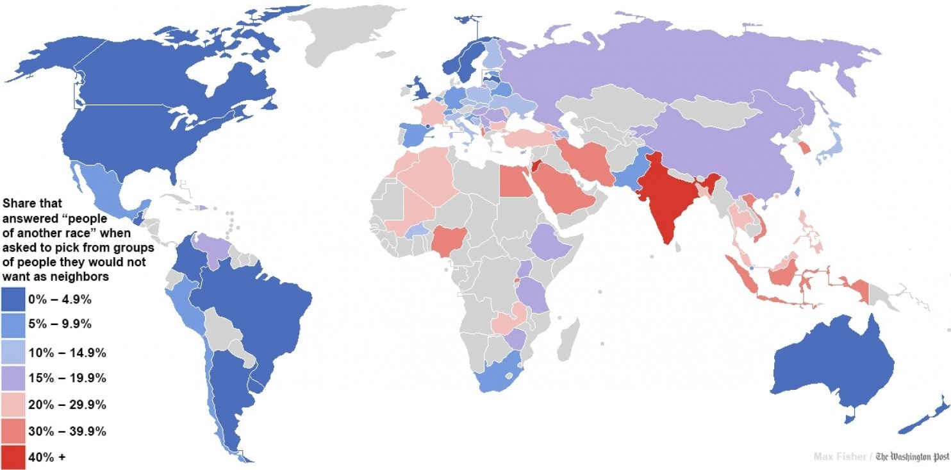
Map: Fisher: Global Racial Tolerance (2013)

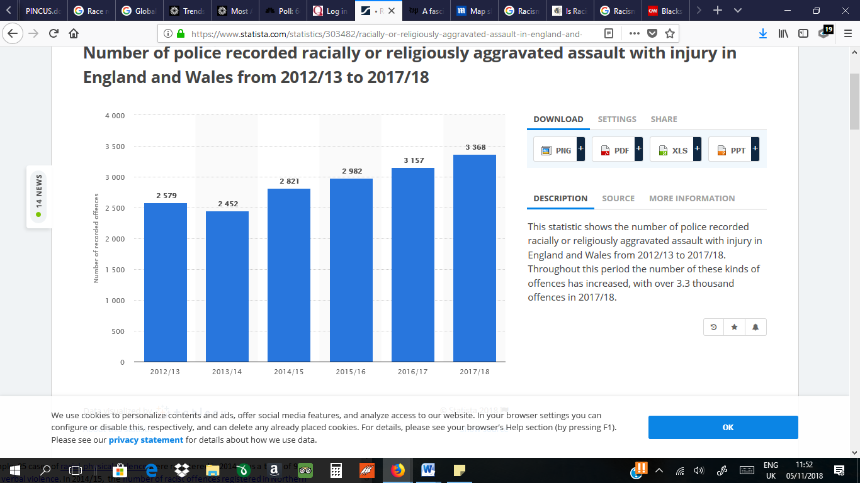

Table 1: This statistic shows the number of police recorded racially or religiously aggravated assault with injury in England and Wales from 2012/13 to 2017/18. Throughout this period the number of these kinds of offences has increased, with over 3.3 thousand offences in 2017/18.

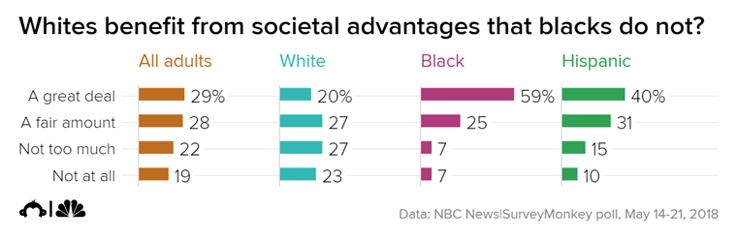
Table 2: Source (CNBC News).

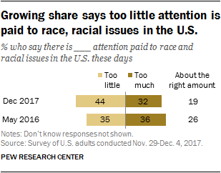
Table 3: Source (Pew Research Center).

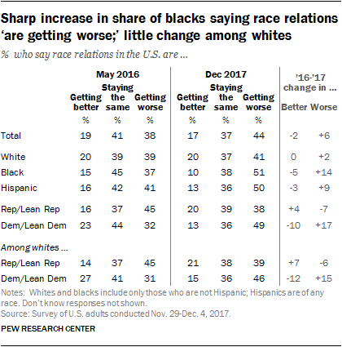
Table 4: Source (Pew Research Center).

